**EXPERIMENT 3**

**AIM :** Write a program to implement the Mid-Point Circle Drawing Algorithm

**THEORY :**

The midpoint circle drawing algorithm is an algorithm used to determine the points needed for rasterizing a circle. We use the midpoint algorithm to calculate all the perimeter points of the circle in the first octant and then print them along with their mirror points in the other octants. This will work because a circle is symmetric about its center.

**ALGORITHM :**

We assign the starting point coordinates (X0, Y0)

as X0 = 0

Y0 = R

We calculate decision parameter P0

P0 = 1 – R

We calculate Pk, (Xk, Yk), and (Xk+1,

Yk+1) If Pk < 0

Pk+1 = Pk + 2Xk+1 +

1 Xk+1 = Xk + 1

Yk+1 = Yk

Else

Pk+1 = Pk + 2Xk+1 + 2Yk+1 +

1 Xk+1 = Xk + 1

Yk+1 = Yk - 1

This will give points in the first quadrant. We will then change signs and get the points in other quadrants.

**CODE :**

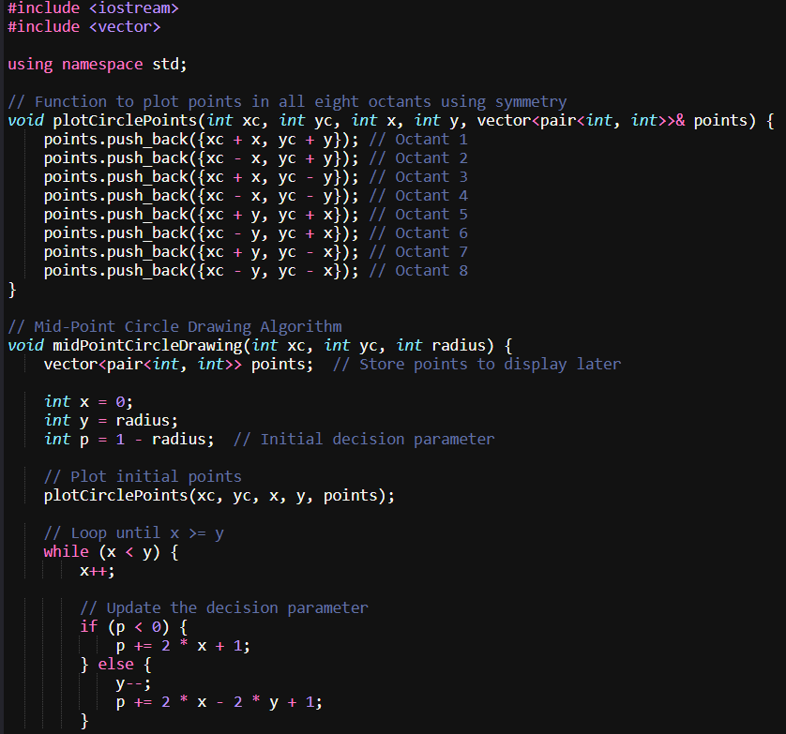

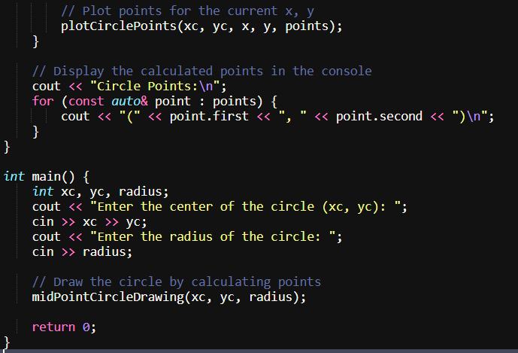

**OUTPUT :**

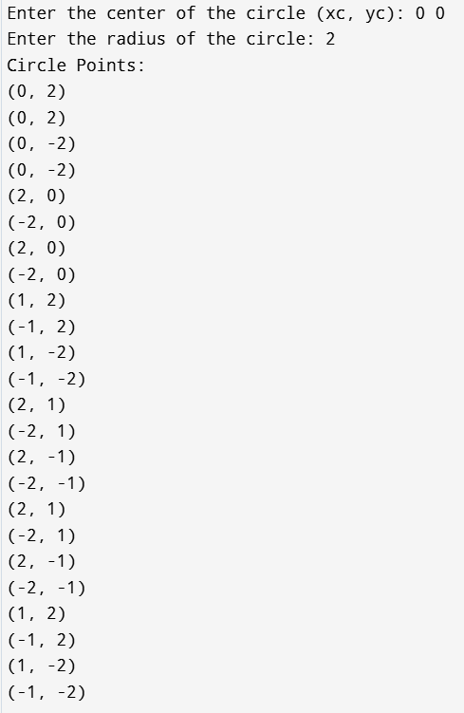

**EXPERIMENT 4**

**AIM :** Write a program to implement MidPoint Ellipse Algorithm

**THEORY :**

Midpoint ellipse algorithm plots(finds) points of an ellipse on the first quadrant by dividing the quadrant into two regions. Each point(x, y) is then projected into other three quadrants

(-x, y), (x, -y), (-x, -y).

**ALGORITHM :**

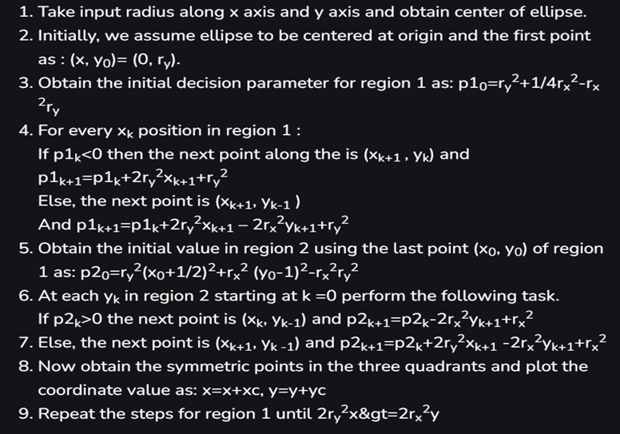

**CODE :**

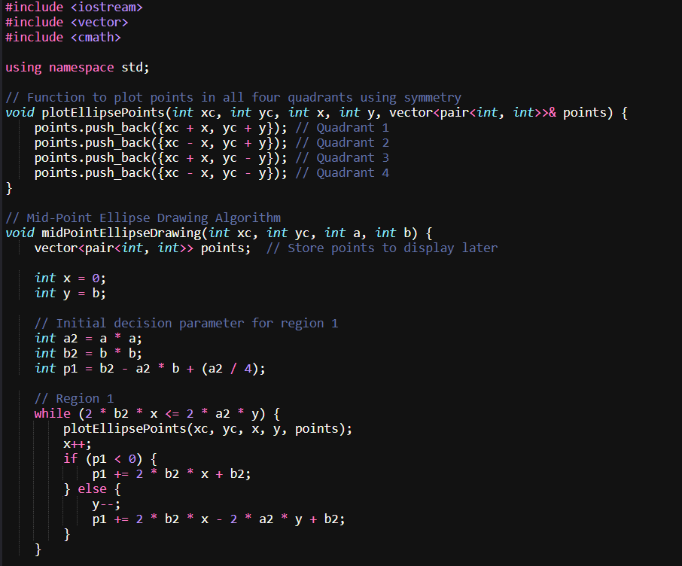

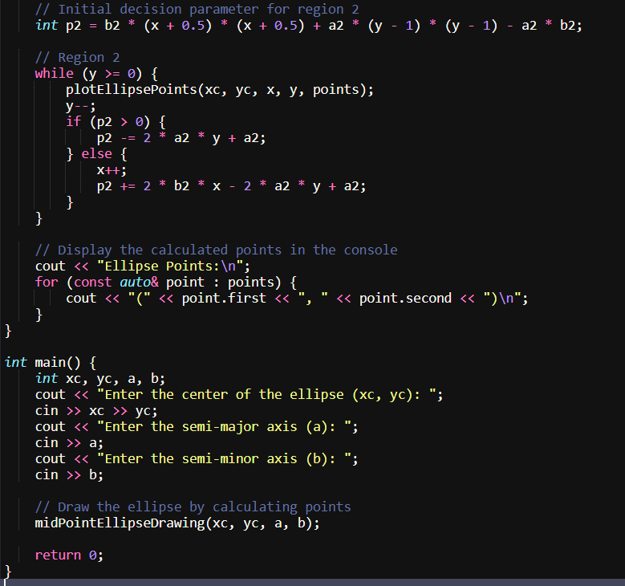

**OUTPUT :**

